React form

Install everytime you wanna use forms in react

**npm install react-hook-form**

**step 2 import**

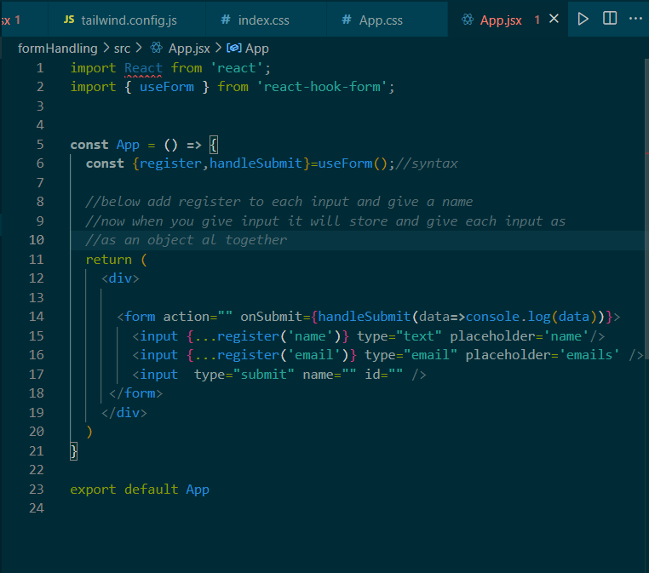



**Use register in the input where you wanna include it in object**

**The name you give for register is the key and it will hold value**

**When you submit the form**

**You will get object as an output which contains all inputs which were registered**

